Power BI Project

Project Title: Airline Data Management and Analysis Using Power BI

- Data Preparation and Cleaning
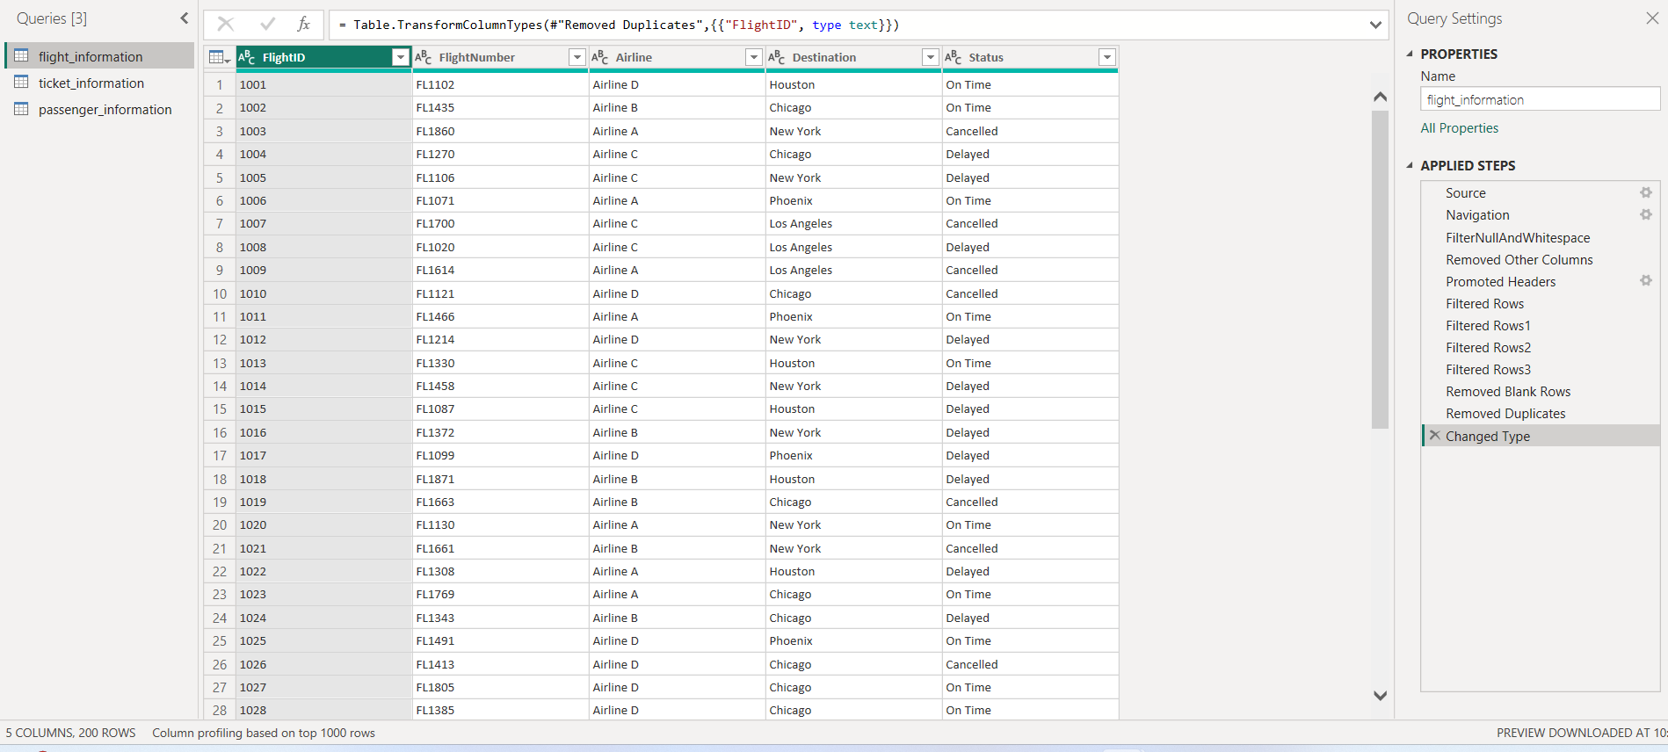
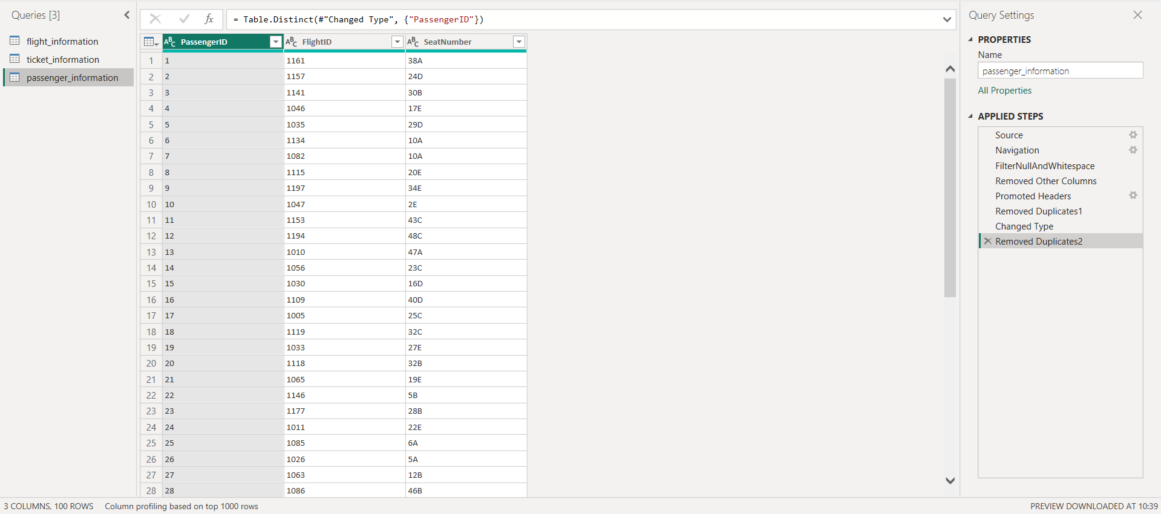
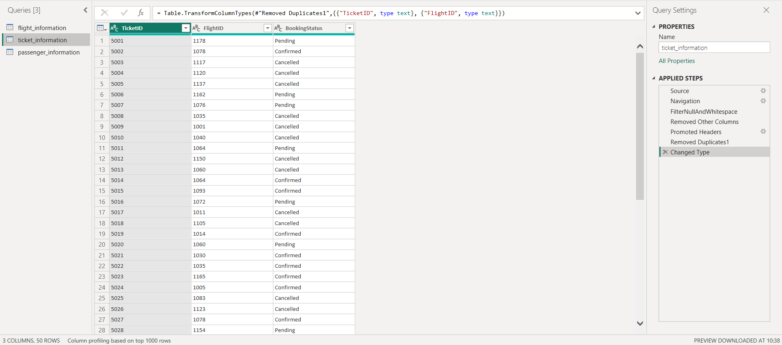
- In this project First I load data which ever needed and then clean date for further analysis
- Clean data checking duplicate for unique value and primary key
- Check duplicate for FLIGHTID, TicketID and PassengerID in flight information, ticket information, passenger information, respectively.
- Also ensuring data is consistent by checking blanks, null, invalid values and assigning each column with proper data type

- Data Modelling
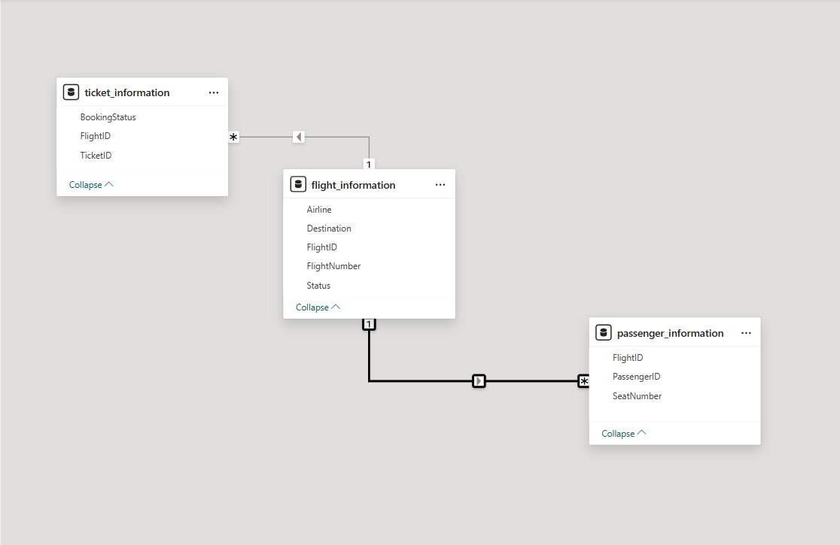
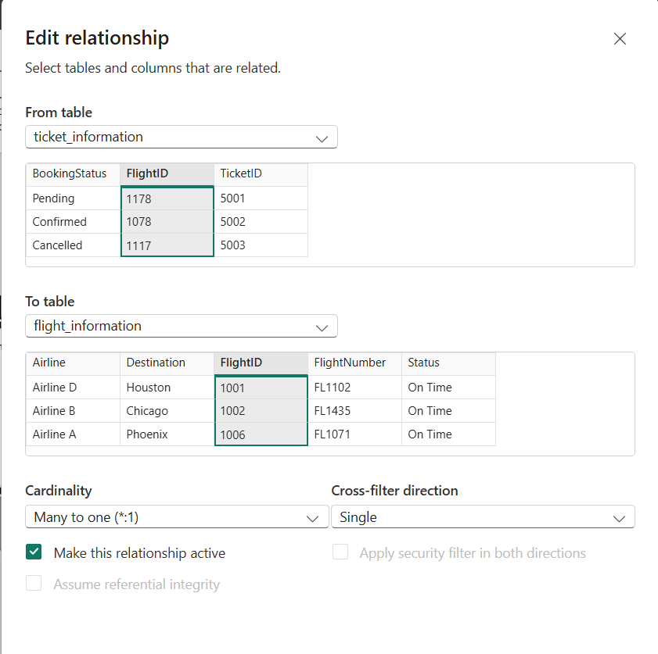

- Relationship created by using flighted as key you can see modelling in above figure
- There is many to one cardinality of ticket information and passenger information with flight information table
- Cardinality of ticket information with flight information is shown in screenshot

- Condition column name flightcondition is created by using condition column feature in add column and applying condition mention in screenshot
- Also extracted number from flighnumber from column from example feature which shown below
- New column created by using condition column and column from example feature is shown in last screenshot

- Enhanced Data Insights

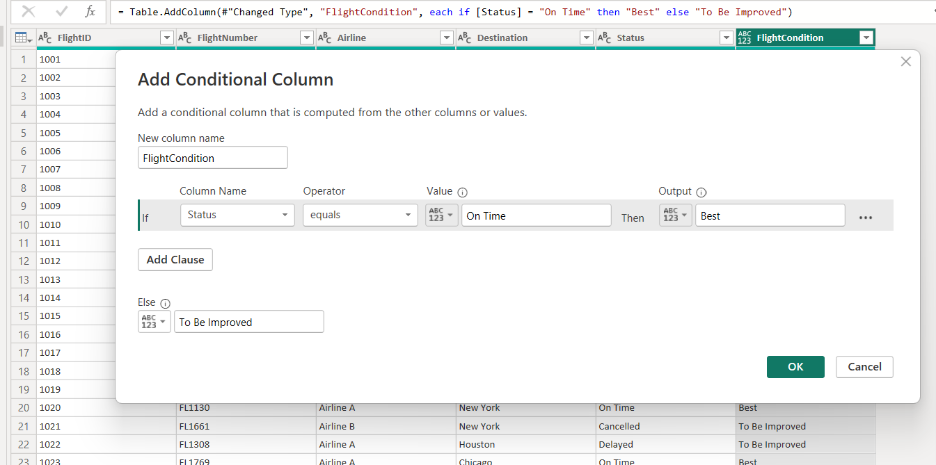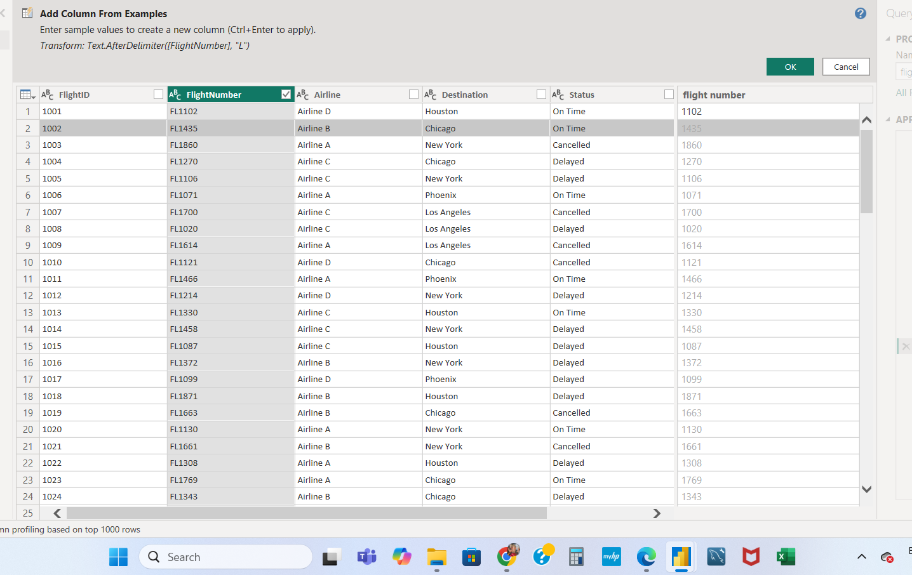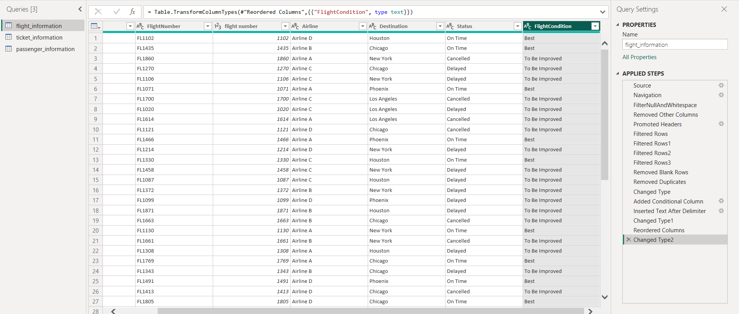

- Calculations Using DAX

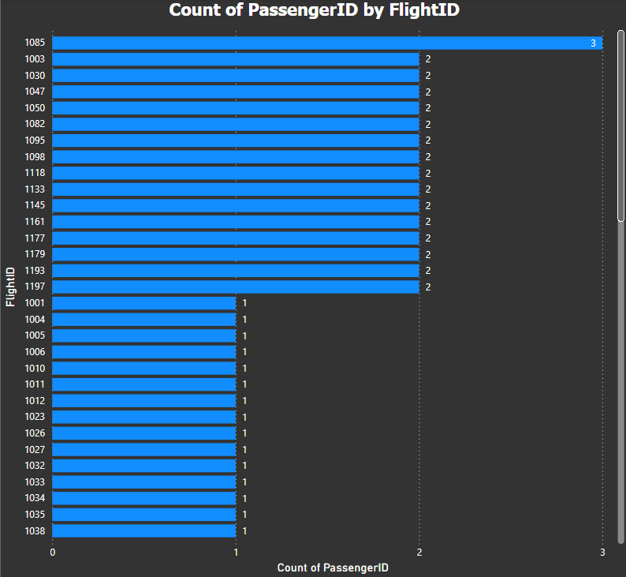
- Total passengers for a specific flight are calculated by dax and its result shown with more formatting
- We can also use count or distinct count instead of countrows function because we have unique value of passenger id

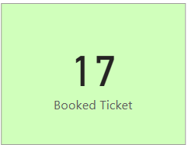
- Total tickets booked calculated using dax function and shown in single card
- We can see dax and single card in above screenshot

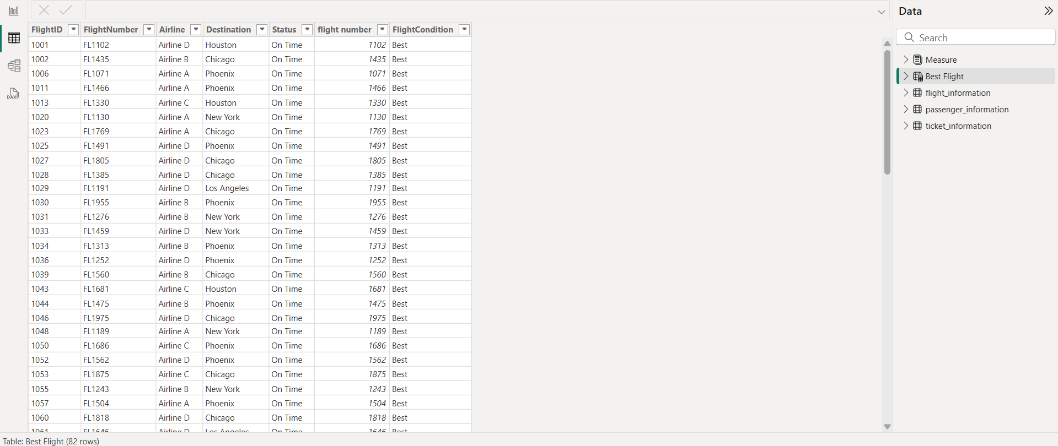
- Filtered table showing "Best" flights only calculated using dax function
- The result table and function shown

- Visualization and Interactive Features

● Create visuals for:

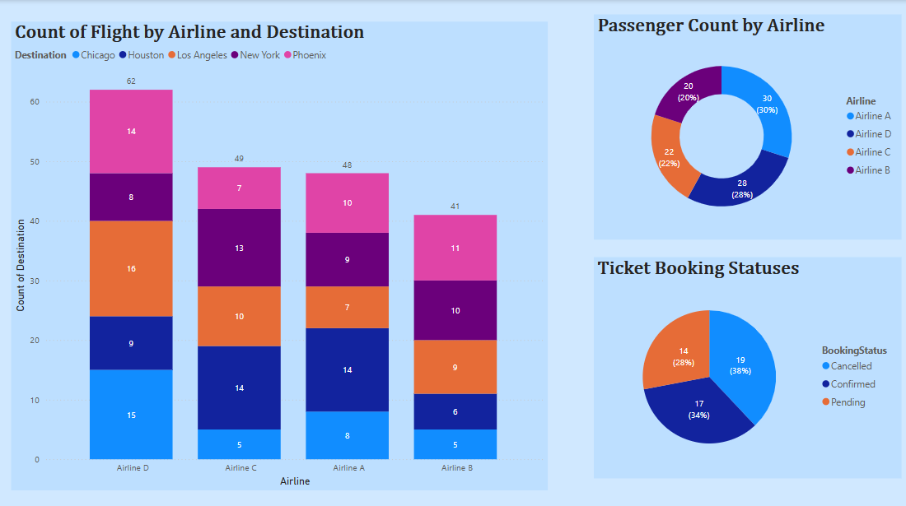
- Visuals for number of passengers by airline, ticket booking status and Flights by airline and destination shown in above visuals

● Add interactive features for:
Destination and Airline:
- first figure represents destination and airline data respective to flight.
- it shows various interactive feature like slicer on different parameters, clearing all slicer button, back button, airline page button which leads to provide page which has all airline related data which you can see in second figure

Quick views: There are different quick views
- Figure 1
1. airline page button to access detail
airline data in fig 2
2. back button to go to drill through page or previous page
- Figure 2
Bookmark button in fig 2 to access destination data in fig 3
- Figure 3
destination button in fig 3 to access destination detail in fig 1

Airline-specific pages
- You can see all airline specific data in fig 2 and bookmark of bookmark in fig 2 interactive feature to view destination data page in fig 3
- Drill through feature in airline data page give detail of destination as you can see in fig 4 and fig 5
- Fig 6 is showing airline specific page is added with more interactive feature by using slicer flight condition and ticket status
(ticket status =custom conditional column created for analysis, process of creation shown in fig 7 and 8)

1
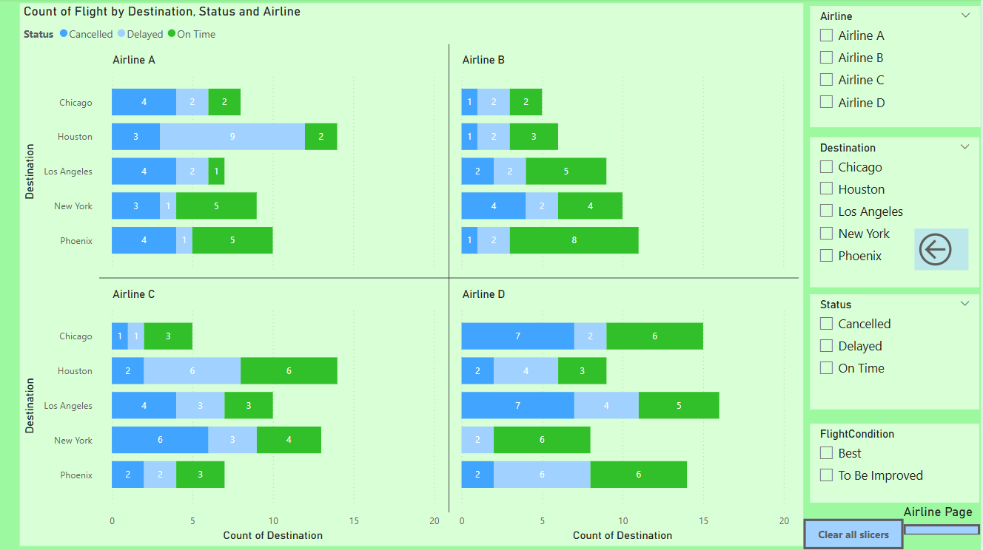
2
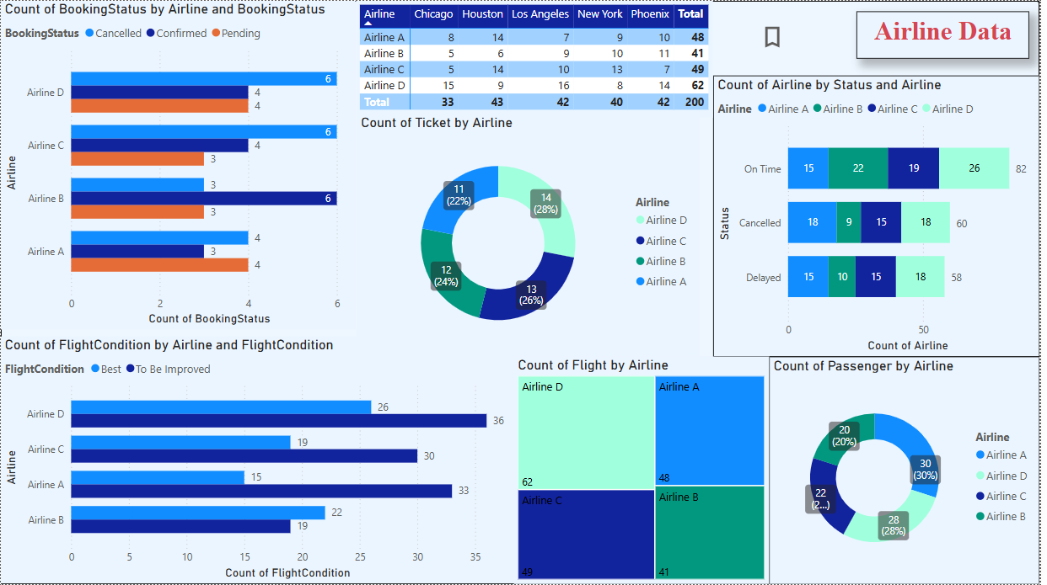

3
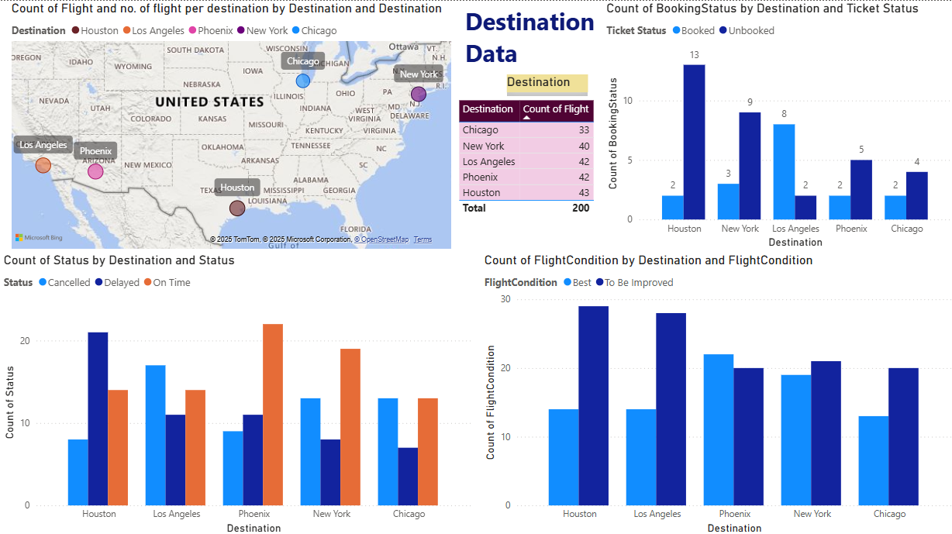

4
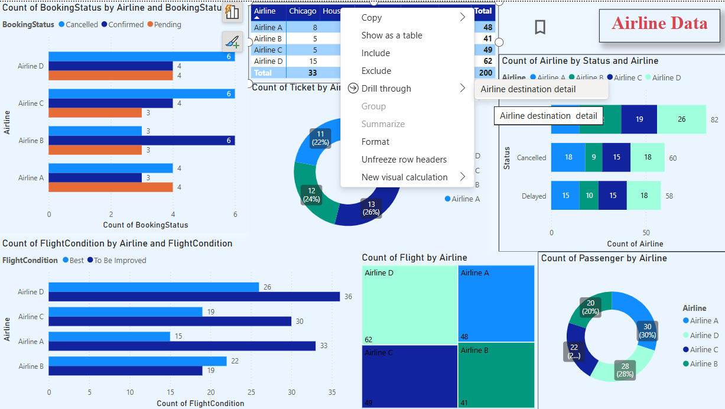

5
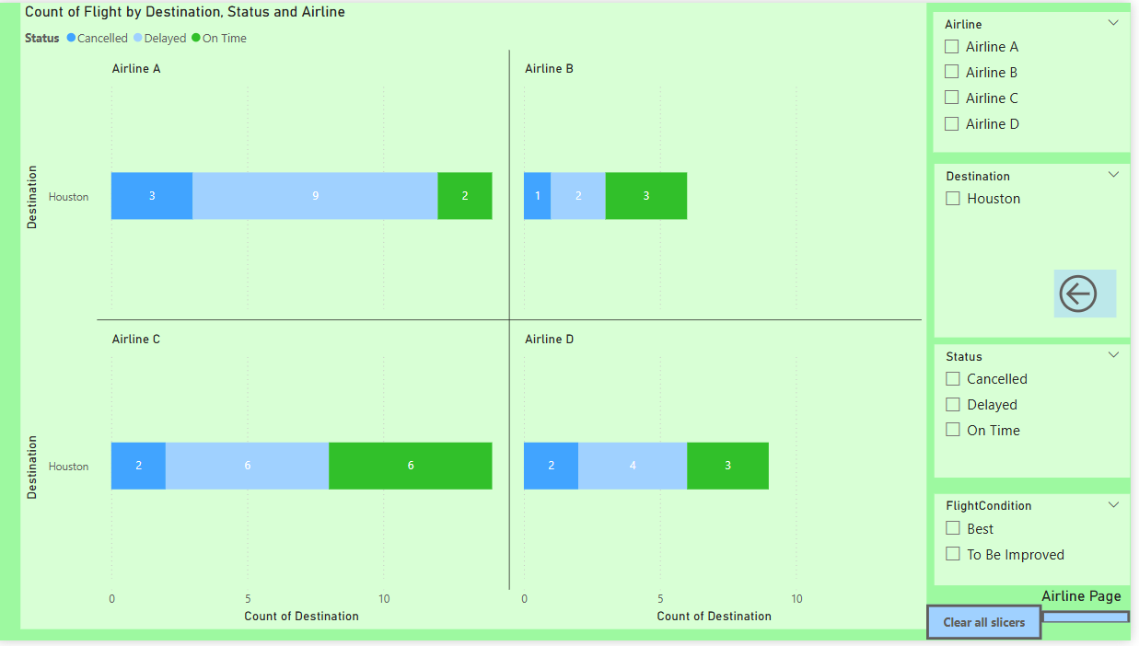
6
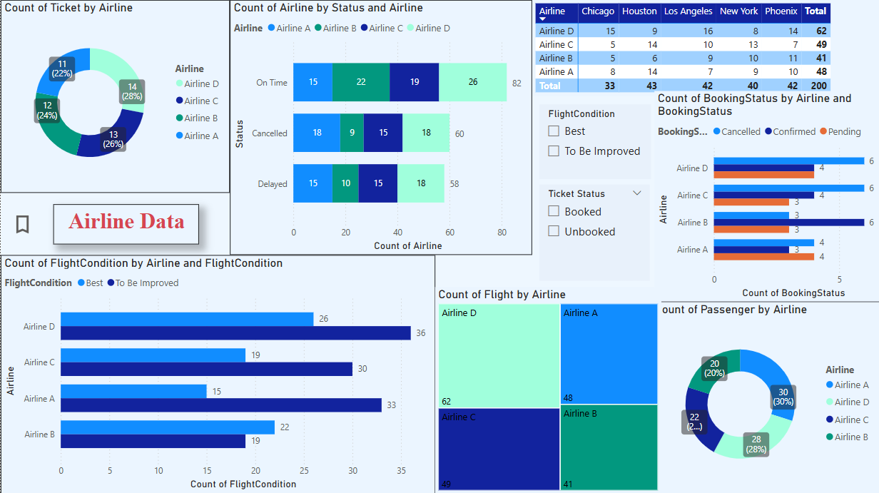

7
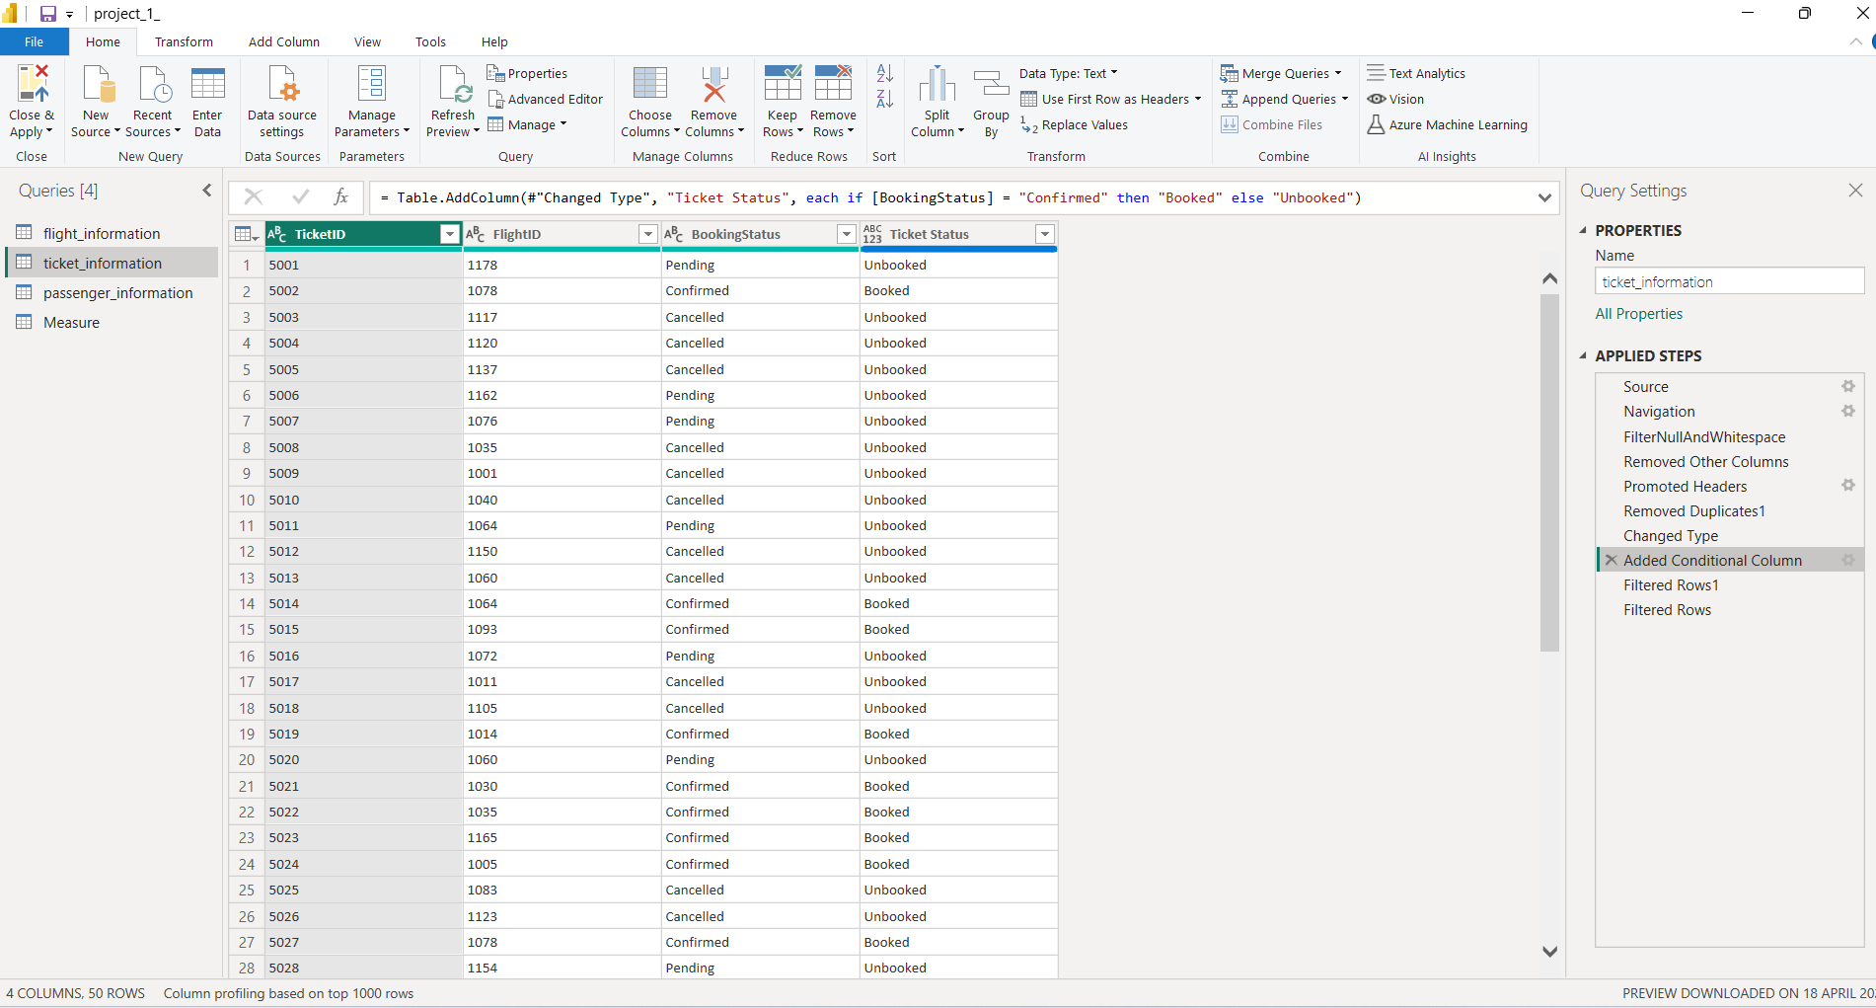

8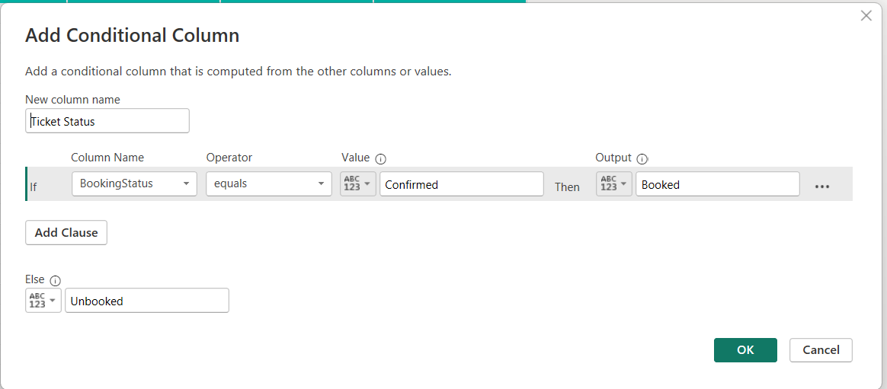

Final Dashboard and Power BI Service

1. comprehensive dashboard
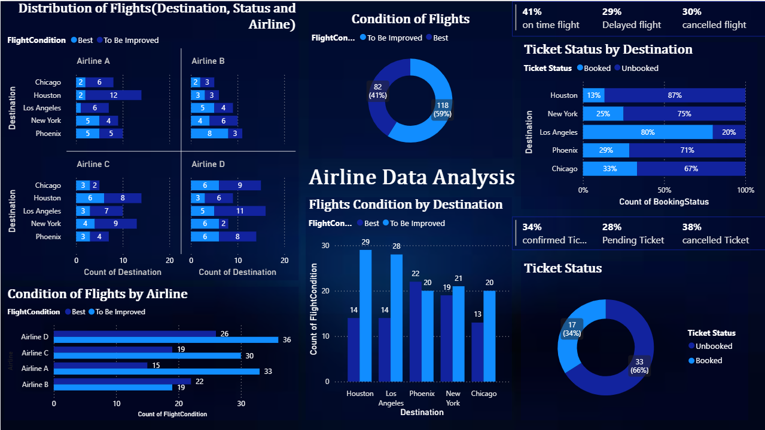

Above figure provide comprehensive dashboard with key visuals and insights for project

Description
- There is total eight visuals in dashboard – 2clustered bar chart, 1clustered column chart,2donut chart,1staked bar chart (100%),2multlirow card
- In dashboard the distribution of flight based on condition of flight is analyse and represented in different visuals to get insight (best=on time; to be improved=cancelled/delayed)
- Also, ticket booking information analyse and represented in different visuals (booked=confirm; unbooked =cancel/pending)
- Dashboard is representing whole project, visual summary and analysis of project for completing project objective

Project analysis and Insights
- There are around 60%flight condition is needs to be improved which is high percentage
- In every parameter of analysis number of best flight less in other words condition needs to be improved (cancelled, Delayed, etc.) are more
- In case of Houston and Los Angeles there are least good flight compared to total flight that does not mean for other its good but actually best flight are average
- Each airline is not showing good trends in best (on time) and to be improved (cancel, delayed) flights but it is worse in case of airline A and less negative in case of airline B
- Getting high confirm booking from Los Angeles while for other their high percentage of not booked ticket
- In analysis there are only 41% percentage on time flight while there are 29% and 30% are delayed and cancelled flight respectively
- Also, only 34% percent are booked while 28% are pending and rest 38% cancelled

All this analysis we can see in above dashboard screenshot

- Row-Level Security (RLS)
All this screenshot provides steps to Configure Row-Level Security (RLS) for Airline A data and assign it to a user

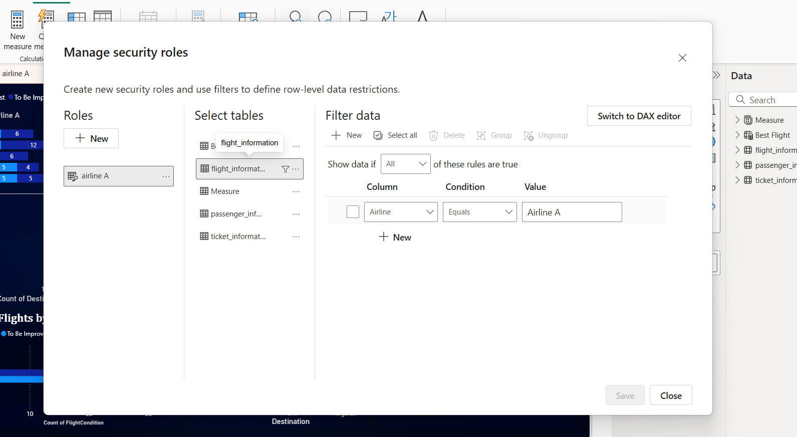

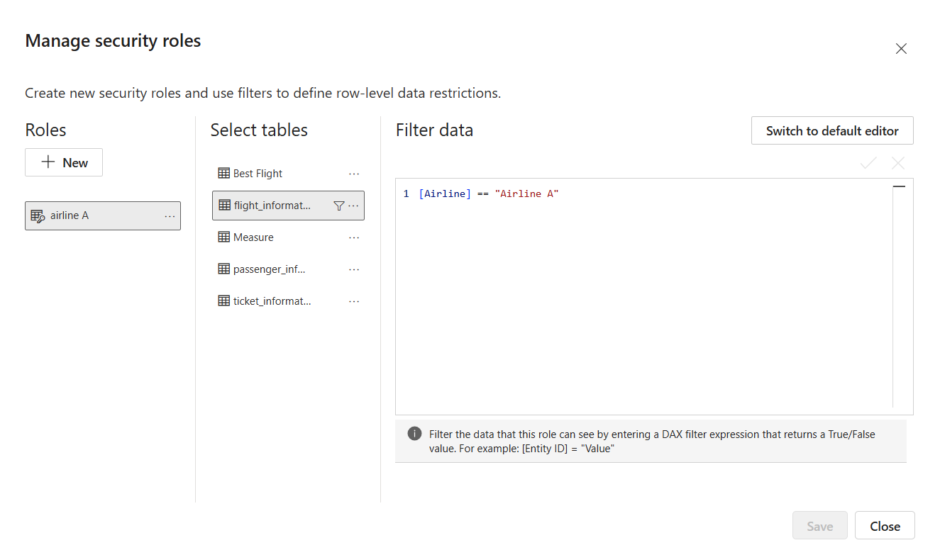

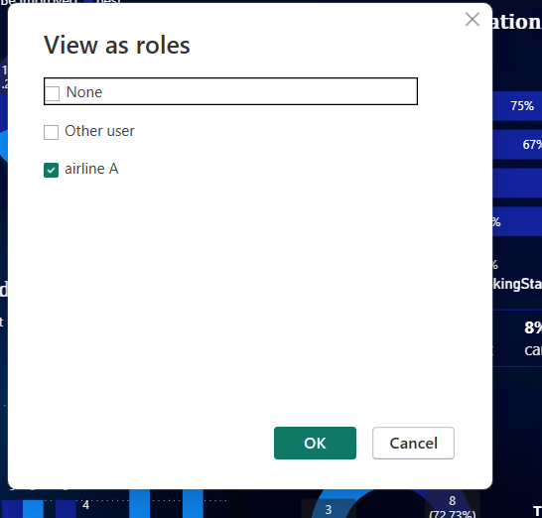

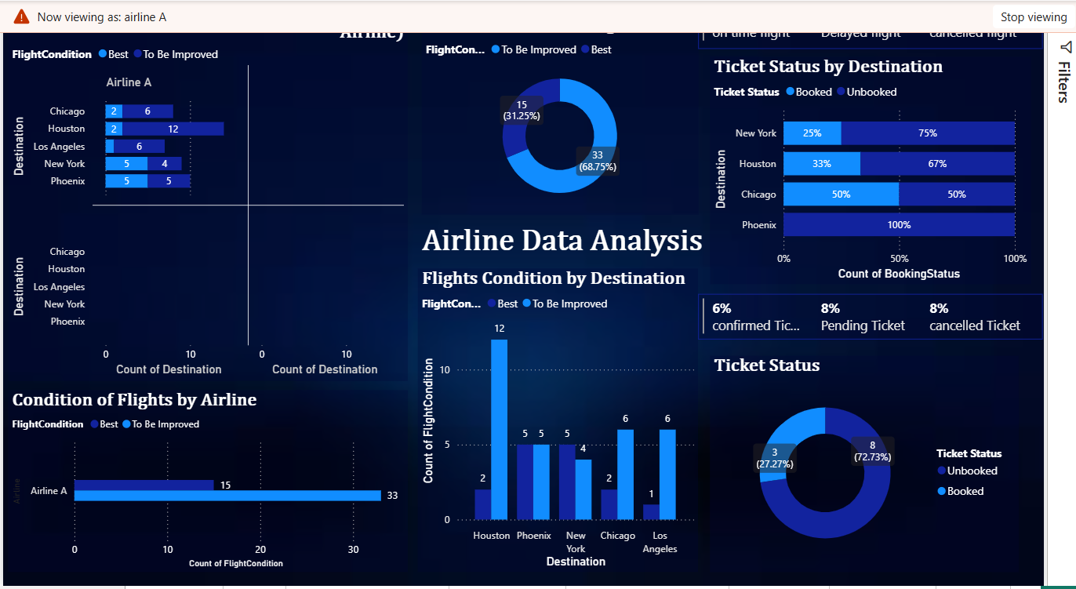

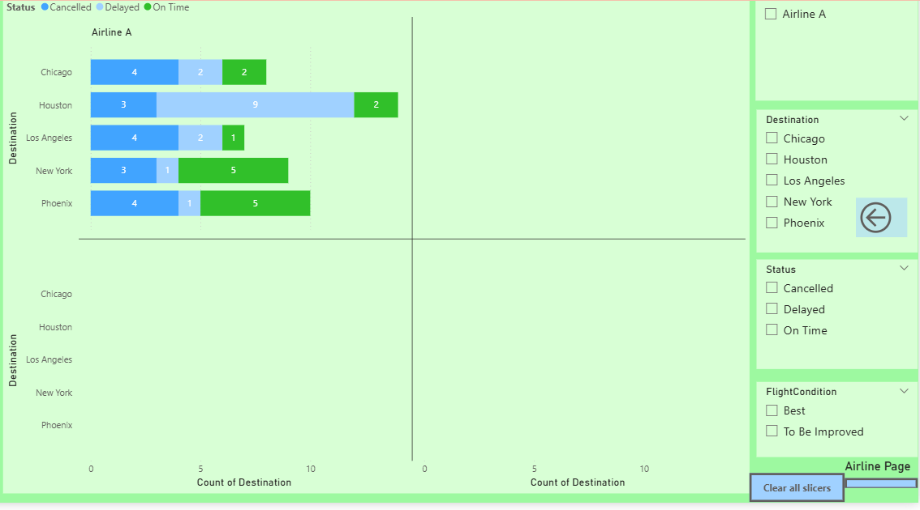
Above two screenshots are visuals applying row level security for airline A in desktop by manage role and view as in modelling tab

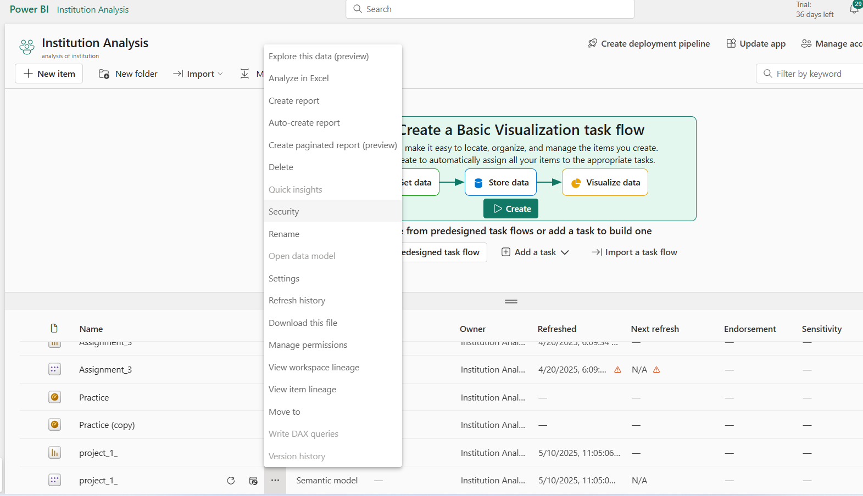
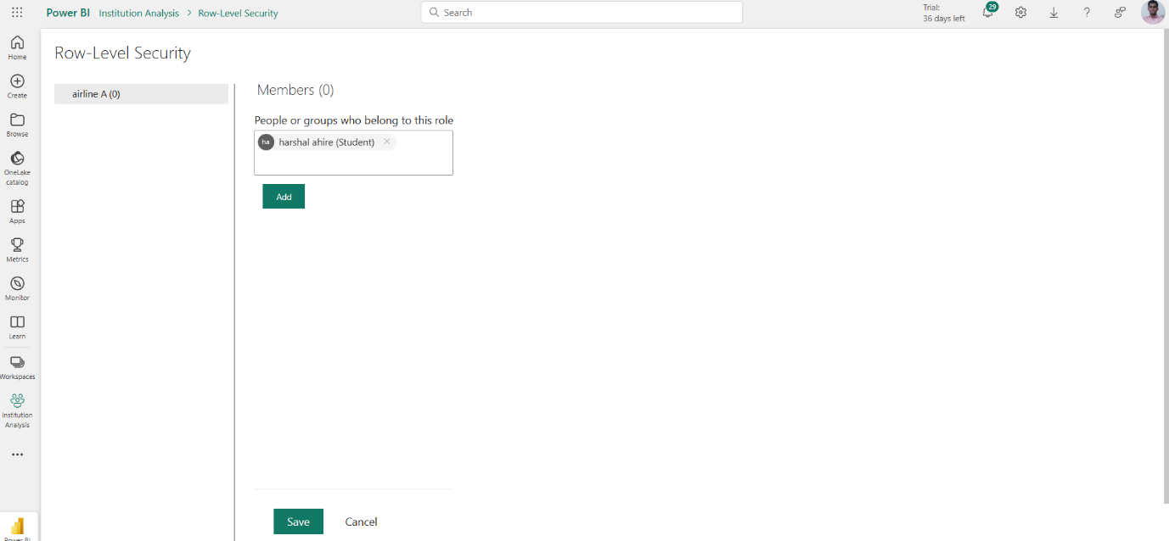

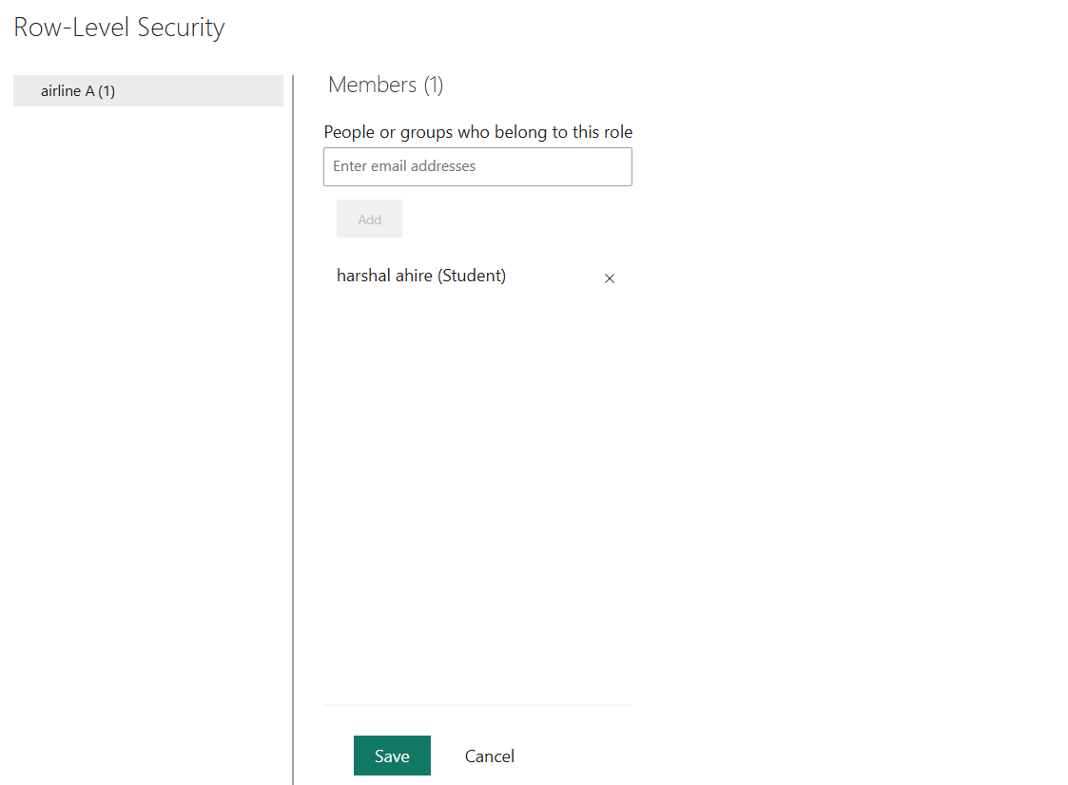

As you can see in above three screenshots Row-Level Security (RLS) for Airline A data and assign it to a user

- schedule refresh

steps
- go to institution analysis where project file was saved
- go to setting > power bi setting > semantic model

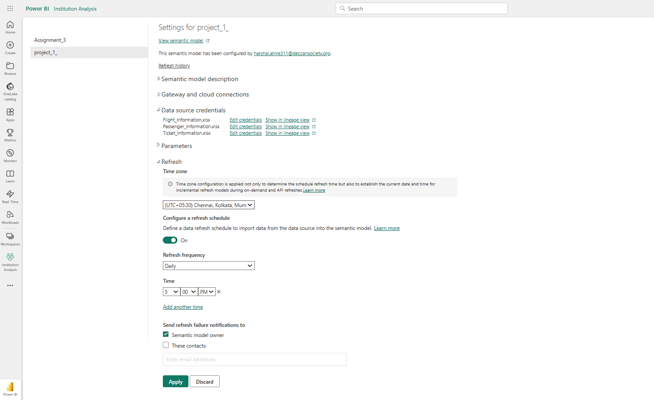

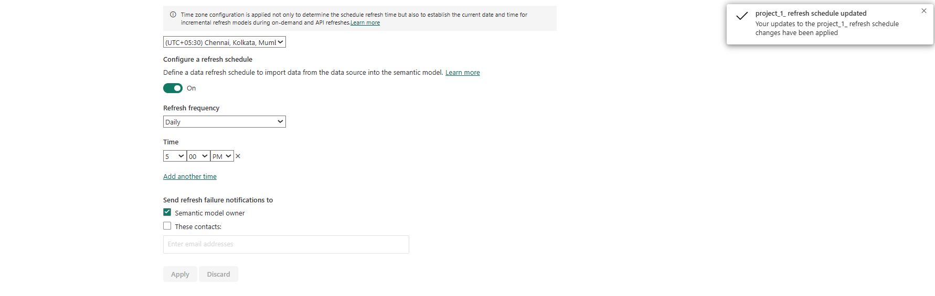

Project suggestion
- find reason of high percentage of to be Improved flight that is 59% percentage and try to shift their status to best flight
- focus on why cancel and pending that is to be improved flight are high in every parameter and overall
- focus on rapid improvement in flight condition for Houston and Los angel which is showing really bad flight condition trend
- implementing airline B strategies in others as airline B is comparatively performing better than other airlines
- finding a reason for such low percentage of booked ticket (34%) and high percent of not booked tickets
- why are ticket are getting cancelled and high percent of ticket are pending, finding solution for it to reduce percent of cancel and pending tickets
- why only Los Angeles showing high percent booking and not other finding reason and gain some positive output from Los Angeles good booking
- also ensure increase best flight condition for Los Angeles due to its high confirm booking rate

